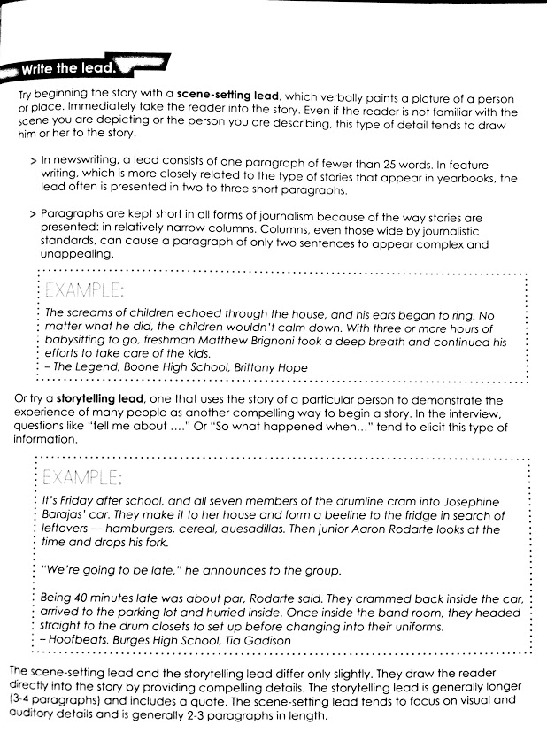

Name

Now It Is Your Turn

DIRECTIONS: You will need to write the lead to your story. You should set the stage and use an attention getter to keep it interesting.

Spread _________________________________________________________________________________

Summarize story in a few words___________________________________________________________________________________

________________________________________________________________________________________

Write your lead in

________________________________________________________________________________________

________________________________________________________________________________________

________________________________________________________________________________________

________________________________________________________________________________________

________________________________________________________________________________________

________________________________________________________________________________________

________________________________________________________________________________________

________________________________________________________________________________________

