Date Name
Word Art: Part 1

What word are you using? ______________________________________________________________________

Sketch it out…

WHAT’S NEXT: Once you have a good working picture drawn up, you will need to 1. Take a photo of this page for your website. 2. You will need to create this in Photoshop. 3. Post it on your website when done.
Date Name
Word Art: Part 2
Your task is to create an image, ONLY USING WORDS. You have to use words that describe the image. They can be repeated. You are allowed to use the following colors: Black, various grays, and one other color.
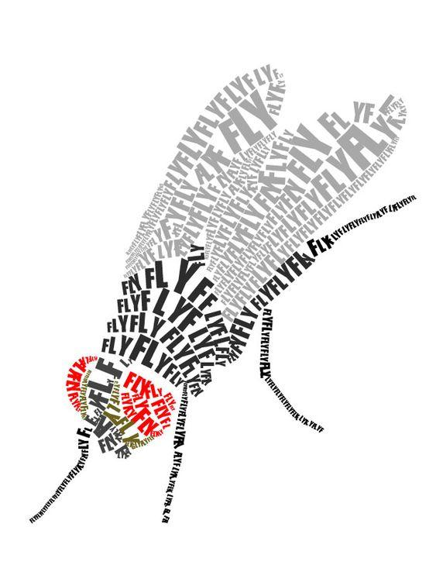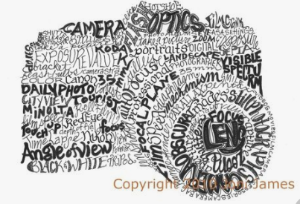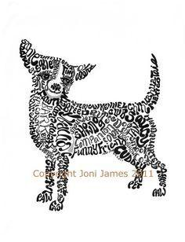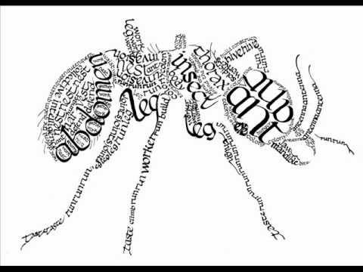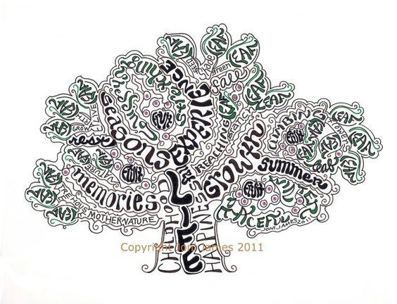
What image are your drawing?

What is your additional color?

What words are you using to describe it (at least 15)?

____________________________ ____________________________ ____________________________

____________________________ ____________________________ ____________________________

____________________________ ____________________________ ____________________________

____________________________ ____________________________ ____________________________

____________________________ ____________________________ ____________________________
WHAT’S NEXT: Once you have an idea, you will need to 1. Show Mr. Shunt so you can get credit. 2. You will need to create this in Photoshop 3. Post it on your website when done.

