Set Up Your Website
- Go to http://www.weebly.com/
- Enter Name, Email, and Password
- Open another browser tab and open your email.
- Start typing an email to yourself: Put weebly in the subject line, and type your password in the body of the email. DO NO SEND YET.
- Select “Site”
- Choose a theme
- Enter a site name in the first box only.
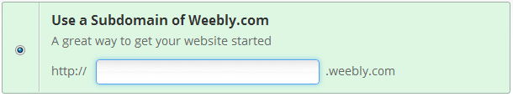
Once the site is created, here are your tasks:
- Name your site (Click on the title and rename it)
- Create a page called “Portfolio” as a standard page
- On the contact page, put in a Contact form so someone can email you.
- On the “About Me” page, you will need to add a Header and Text box. Your header should say “About Me”. In the text box, write the following questions and type your answers in complete sentences.
  - First Name:
  - City I live in:
  - Favorite color:
  - Favorite food:
  - Favorite TV show or movie:
  - If I could travel anywhere in the world right now, I would go to:
  - Favorite band or song:
  - Favorite season:
  - What will I be doing in ten years:
- Publish your site (This will make it live for the world to see). Select the first box.
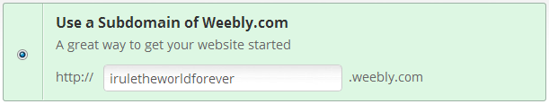
- Category for your site should be personal
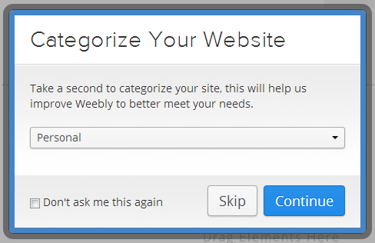
- Verify that you are human.
- Click the link to open your live site.
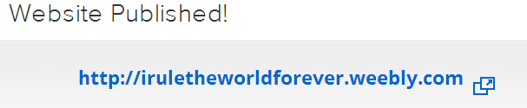

- Also Copy the link and send it to me in an email. REMEMBER, I DO NOT RESPOND OR READ EMAILS THAT ARE NOT PROPERLY FORMATTED. YOU MUST INCLUDE A SUBJECT LINE, IN THIS CASE, WEEBLY WEBSITE WILL DO. YOU MUST INCLUDE A PROPER GREETING, HELLO MR. SHUNT, OR DEAR MR. SHUNT. YOU MUST WRITE THE BODY OF THE EMAIL, EX. “I AM SENDING YOU THE WEBSITE I CREATED FOR CLASS. HERE IS THE LINK.” YOU MUST INCLUDE A CLOSING, EX. “ HAVE A GREAT DAY, LARRY” OR “THANKS, LARRY”

- Never use all capitals in your email.
I CANNOT GRADE YOUR WEBSITE IF YOU DO NOT EMAIL IT TO ME.

