Period Date Name
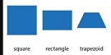
Haunted House
Sketch haunted house. You will be limited to squares, rectangles, and trapezoids.

You can use the image online as a guide, but you should create your own image.
DO NOT add a bunch of details because you might not have the knowhow yet to
create them in Photoshop. Stick with the shapes to the right. You can also add circles.
I will show you how to create the background and grassy areas. Those should be similar
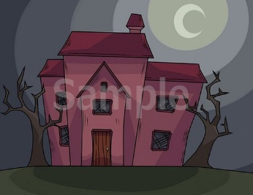
to the one online.

