Period Name
Points
---------------------------------------
Annotation = 15pts
Questions = 15pts (5pts each)

DIRECTIONS:
A. Annotate the text below:
- Underline important terms.
- Circle definitions and meanings.
- Write key words and definitions in the margin.

B. On a separate sheet of paper, answer the questions in
complete sentences, citing the article.
QUESTIONS:
- Explain how balance is used in Egyptian art.
- Explain a variety of techniques used in Egyptian art.
- Explain functional art.

-------------------------------------------------------------------------------------------------------------------------------------------

Ancient Egyptian Art was Created to be Useful

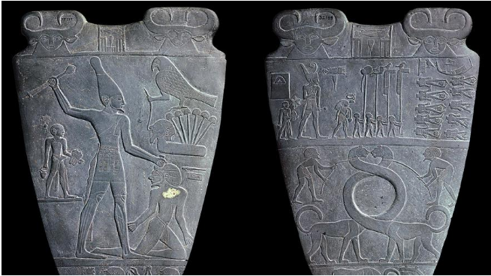
The Narmer Palette, also known as Narmer's Victory Palette and the Great Hierakonpolis Palette, is an Egyptian ceremonial engraving, depicting the First Dynasty King Narmer conquering his enemies and uniting Upper and Lower Egypt. It features some of the earliest hieroglyphics found in Egypt and dates to around 3150 B.C. Photo from Wikimedia.

The artworks of ancient Egypt are highly regarded today, and people flock to museums to see them. Early Greek and Roman artists were influenced by Egyptian techniques. Egypt's art has inspired those of other cultures up to the present day. But while we know many Greek and Roman artists, most Egyptian artists are completely unknown. There's an interesting reason for this. Egyptian art was created for a practical purpose. It is unlike today's art, which is created mostly for visual pleasure.

Egyptian art was meant to serve a practical purpose. A statue held the spirit of the god or the deceased. A tomb painting showed scenes from one's life on earth so that one's spirit could remember it. Charms and amulets protected one from harm. Figurines warded off evil spirits and angry ghosts. Ceramics were used for drinking, eating and storage. In fact, Egyptians had such a practical view of decorative items that, as far as we know, they had no word for our concept of art.

Everything has balance
This is not to say the Egyptians had no sense of visual beauty. Even Egyptian hieroglyphics were written with aesthetics in mind. A hieroglyphic sentence could be written left to right or right to left, up to down or down to up, depending entirely on how one's choice affected the beauty of the finished work. But the goal of this was to produce something functional.

The perfect balance in Egyptian art reflects the cultural value of ma'at (harmony), which was central to Egyptian civilization. Ma'at was not only the foundation upon which Egyptian society was built, but was also the very fabric of creation that came into being when the gods made the ordered universe out of chaos. The concept of unity, of oneness, was this "chaos," but then the gods introduced duality — night and day, female and male, dark and light — and this duality was regulated by ma'at.

Egyptians placed great emphasis on balance. Temples, palaces, homes and gardens, statuary and paintings, signet rings and amulets were all created with balance in mind. The Egyptians believed their land had been made in the image of the world of the gods, and when someone died, they went to a paradise they would find quite familiar. When an obelisk was made, it was always created and raised up with an identical twin. Meanwhile, these two obelisks were thought to have divine reflections, made at the same time, in the land of the gods (the afterlife). Temple design was supposed to be the same as in the afterlife. Art reflected the perfection of the gods, and also served a practical purpose in daily Egyptian life.

King Tut's mask and other famous works
The art of Egypt is the story of the elite, the ruling class. One of the first famous pieces is the Narmer Palette from the Early Dynastic Period (around 3150-2613 B.C.). This two-sided ceremonial plate of siltstone is a masterpiece of balance designed to honor King Narmer. The later work of the architect Imhotep (around 2667-2600 B.C.) on the step pyramid of King Djoser (around 2670 B.C.) reflects how far artworks advanced after the Narmer Palette. Djoser's pyramid complex contains intricate artwork and showed the Egyptian skill in creating stone monuments.

Art also flourished during the Middle Kingdom (2040-1782 B.C.), which is generally considered the high point of Egyptian culture. Colossal statues began during this period as did the great temple of Karnak at Thebes. Statues and paintings tended to show realistic representations, and the lower classes were also found represented more often in art than previously.

The New Kingdom (around 1570-1069 B.C.) is the best-known period of Egypt's history. It produced some of the finest and most famous works of art. The bust of Nefertiti and the golden death mask of Tutankhamun both come from this era.

The techniques of ancient artists
Although home, garden, and palace walls were usually decorated with flat two-dimensional paintings, tomb, temple and monument walls used reliefs. There were high reliefs (in which the figures stand out from the wall) and low reliefs (where the images are carved into the wall). To create these, the surface of the wall would be covered with plaster that was then sanded smooth. An artist would create a work in miniature and then draw grid lines on it, and this grid would then be drawn on the wall. Using the smaller work as a model, the artist would be able to replicate the image in the correct proportions on the wall.

Stone work became more and more refined over the centuries. A sculptor would work from a single block of stone with a copper chisel, wooden mallet and finer tools for details. The statue would then be smoothed with a rubbing cloth. The stone for a statue was selected, as with everything else in Egyptian art, to tell its own story. A statue of the god Osiris, for example, would be made of black schist stone to symbolize fertility and rebirth, both associated with Osiris.

Metal statues were usually small and made of copper, bronze, silver and gold. Gold was particularly popular for amulets and shrine figures of the gods, since it was believed that the gods had golden skin. These figures were made by casting or putting sheet metal work over wood. Wooden statues were carved from different pieces of trees and then glued or pegged together.

Cosmetic chests, coffins, model boats and toys were made in this same way. Jewelry was commonly made using the technique known as cloisonne. Thin strips of metal were inlaid on the surface of the object and then fired in a kiln to forge them together and create compartments. These were then detailed with jewels or painted scenes. Among the best examples of cloisonne jewelry is the Middle Kingdom pendant given by Senusret II (around 1897-1878 B.C.) to his daughter. This work is fashioned of thin gold wires attached to a solid gold backing inlaid with 372 colorful stones.

Egyptian art reflects an eternal journey
Although Egyptian art is famously admired, it has come under criticism for being unrefined. Critics claim that the Egyptians art is always two- dimensional and that the figures lack any emotion. These criticisms fail to recognize that Egyptian art was mostly functional. The spirit in the afterlife might not recognize a statue of an angry or jubilant version of themselves, but it would recognize their calm features. Life was only a small part of an eternal journey to the ancient Egyptians, and their art reflected this belief.

