Board Game Concept Art

Period ______ Name _____________________________________________________ Due Date ____________

You will create a mock-up of the board.
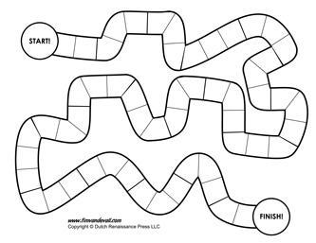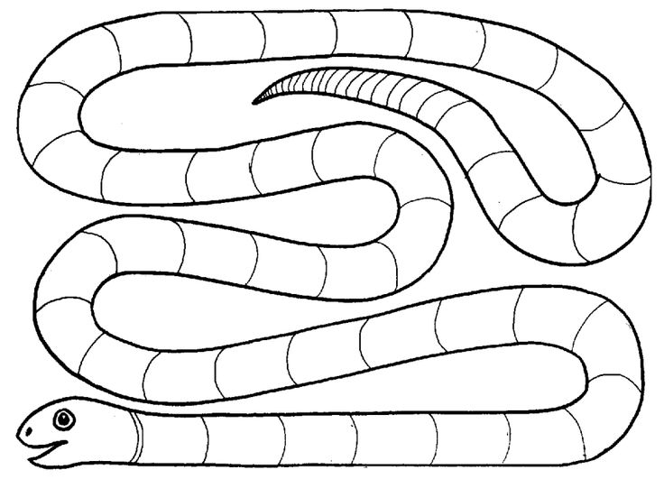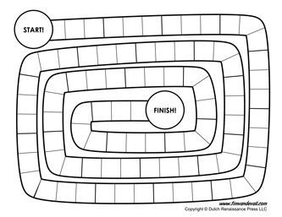

You will need 50 sports for players to move through.
You will need 2 shortcuts, this can happen with playing cards.
You will need to design this so it is interesting.
You need a start and finish/winner’s spot.

