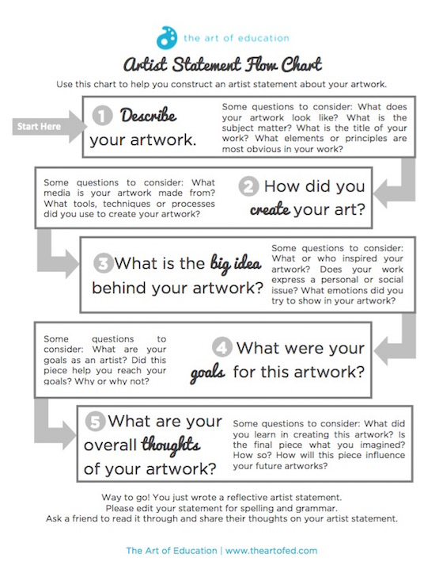

Period Date Name
Artist Statement

1

2
3

4
5

